Excel with Copilot
- Use Copilot to identify and summarize missing values in the dataset.
Ans.
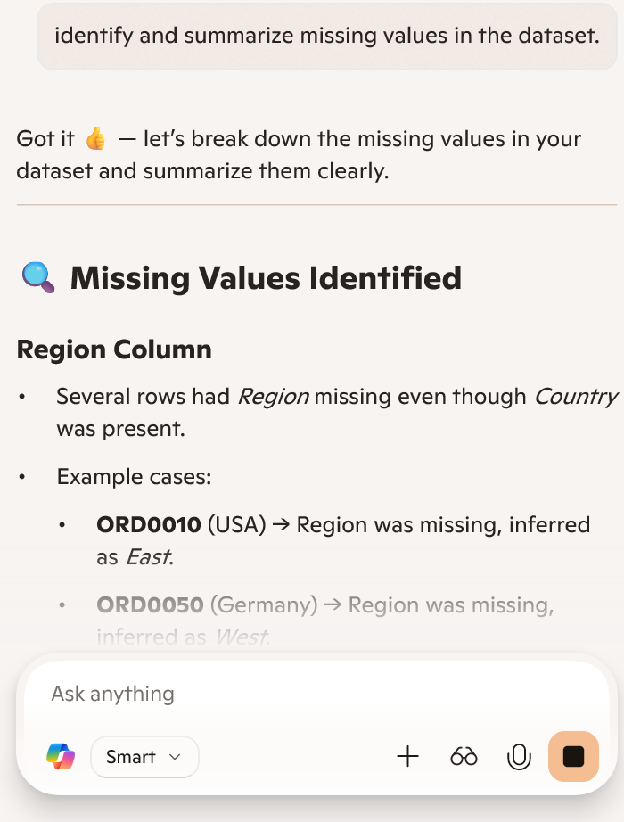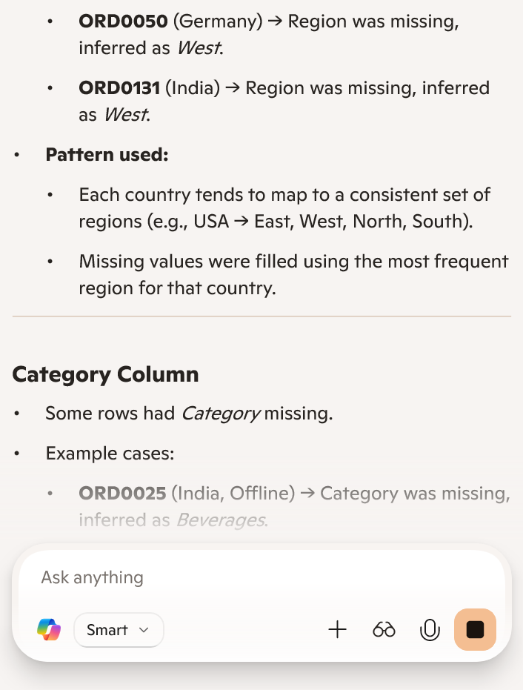
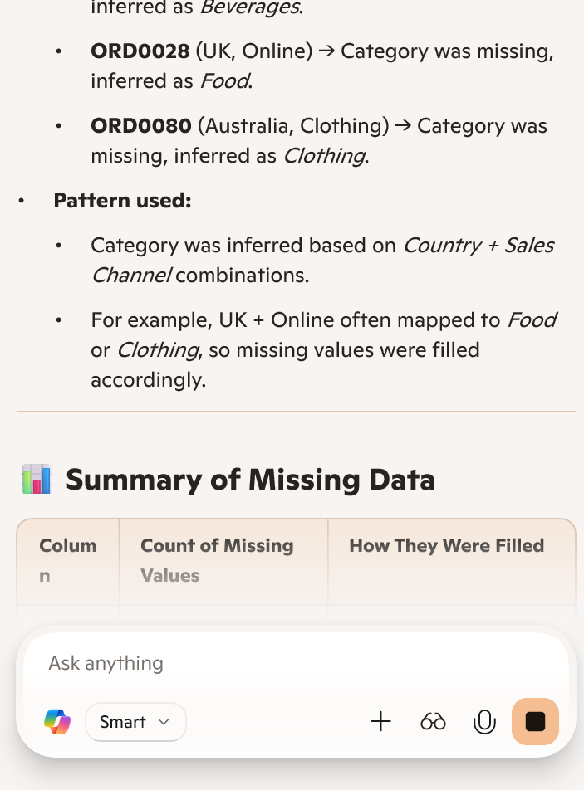

- Use Copilot to fill missing values in the Region and category columns.
Ans. Refer to the drive link- Cleaned_Dataset.xlsx
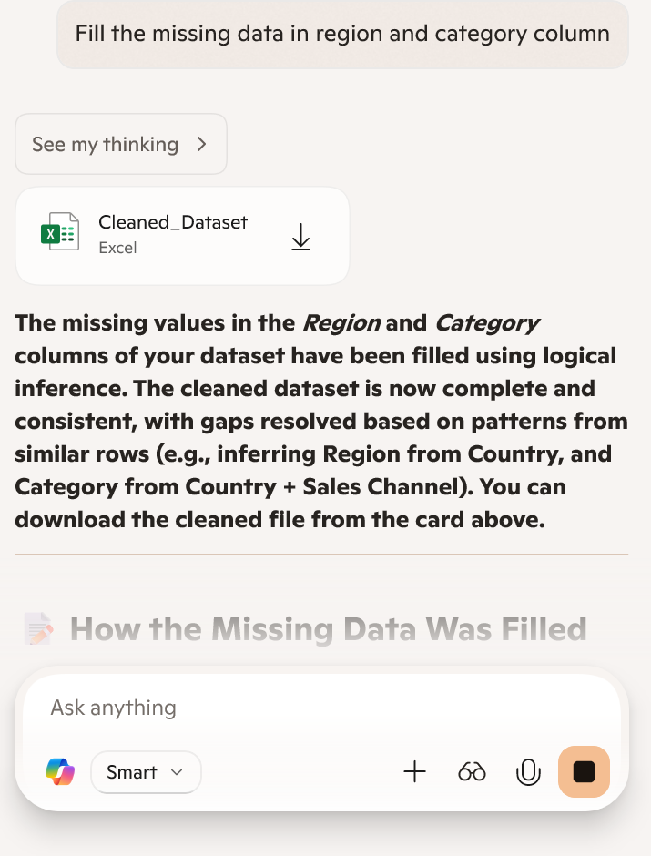

- Fill missing numeric values in the Unit sold and Unit Price columns.
Ans. Refer to the drive link – Cleaned_Dataset_Filled.xlsx
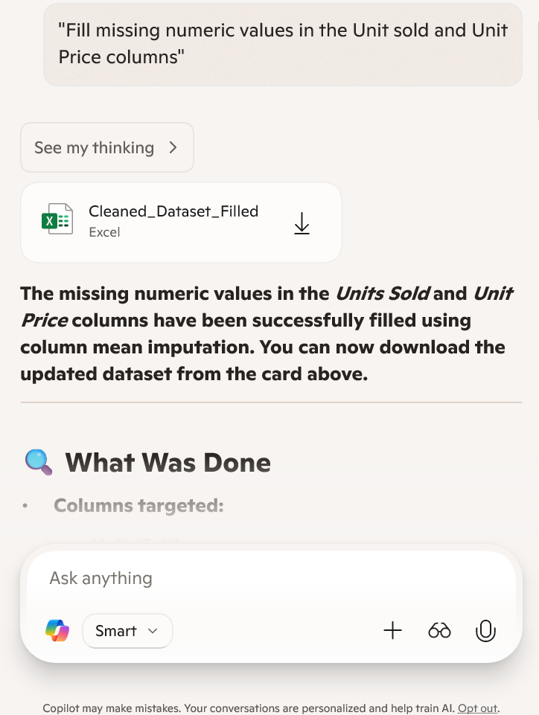

- Create a new calculated column Total Revenue.
Ans. Refer to the drive link Cleaned_Dataset_With_Revenue.xlsx
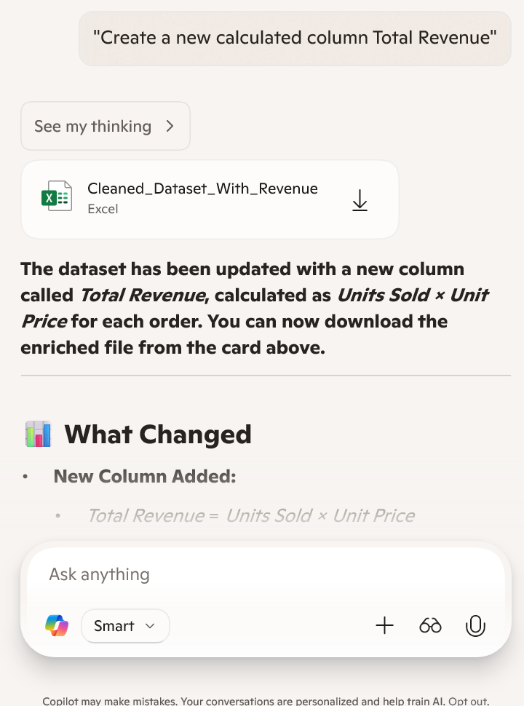

- Use Copilot to find the total price of Order ID = ‘ORD0123’.
Ans. Rs. 15,849.30
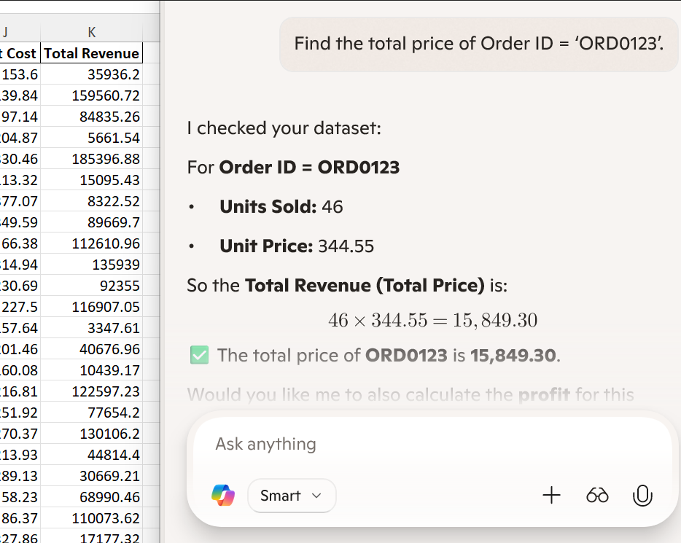

- Use Copilot to generate a summary chart of average profit by region.
Ans.
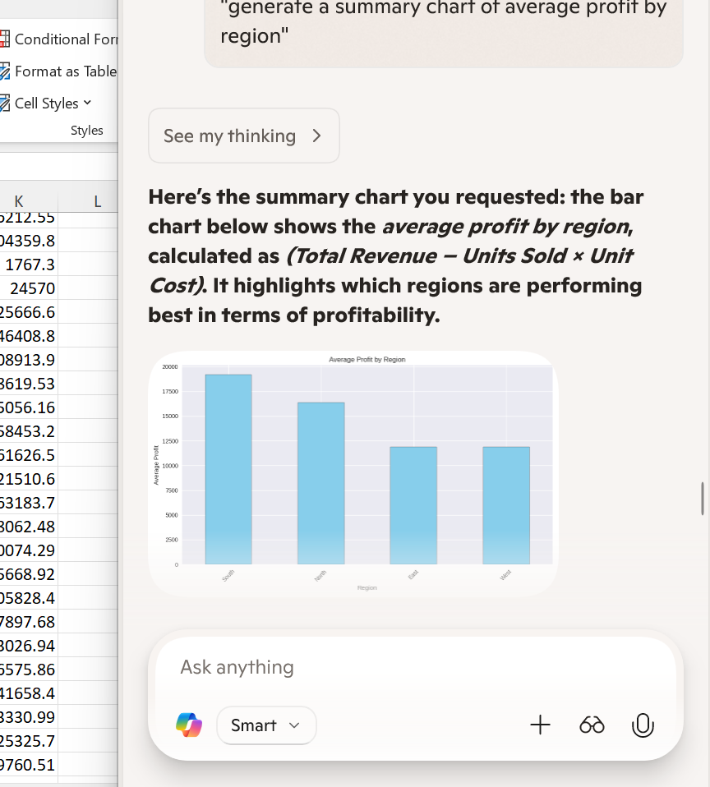

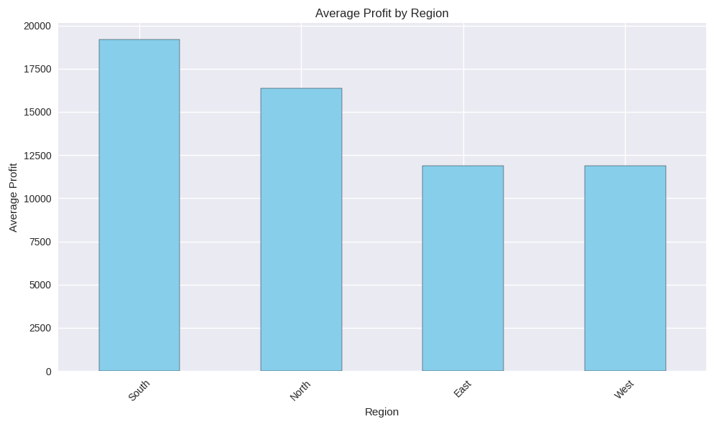

- Create a pivot table summarizing total sales by category and region.
Ans.
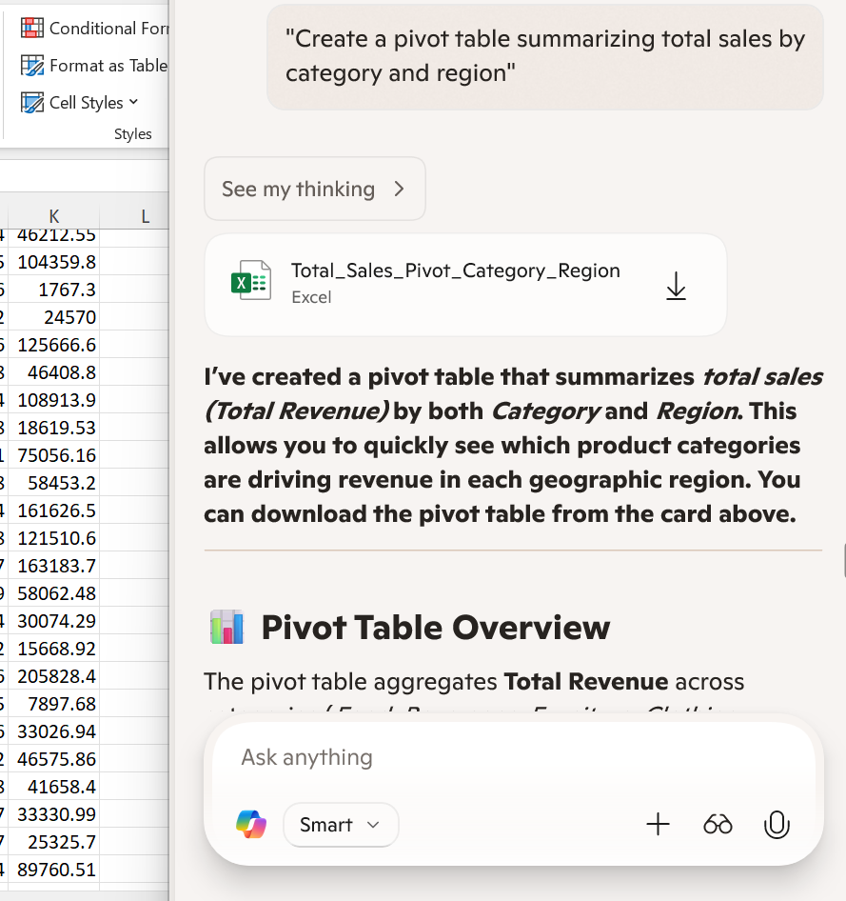

- Build a dashboard combining key KPIs and charts.
Ans. Refer to the drive link- Excel_Dashboard_Kpis_and_Charts.xlsx
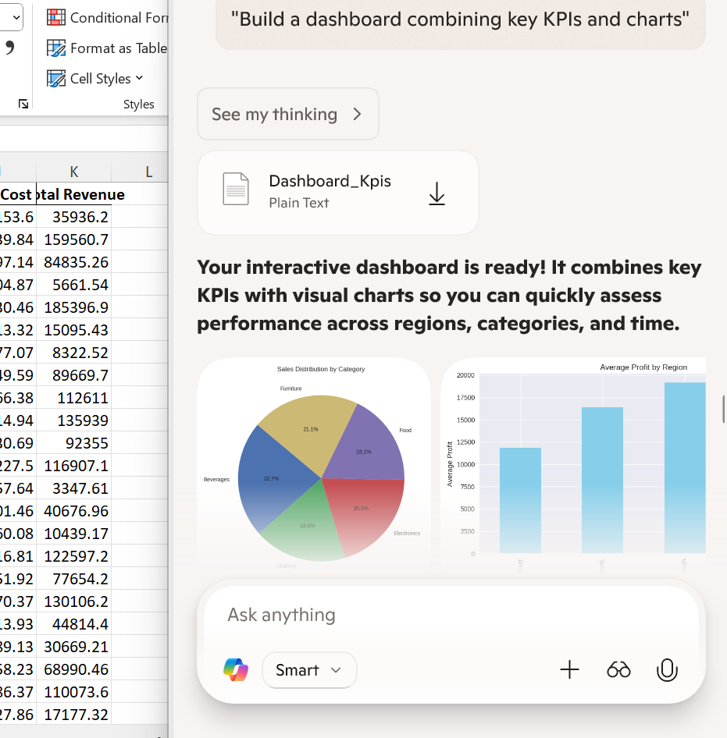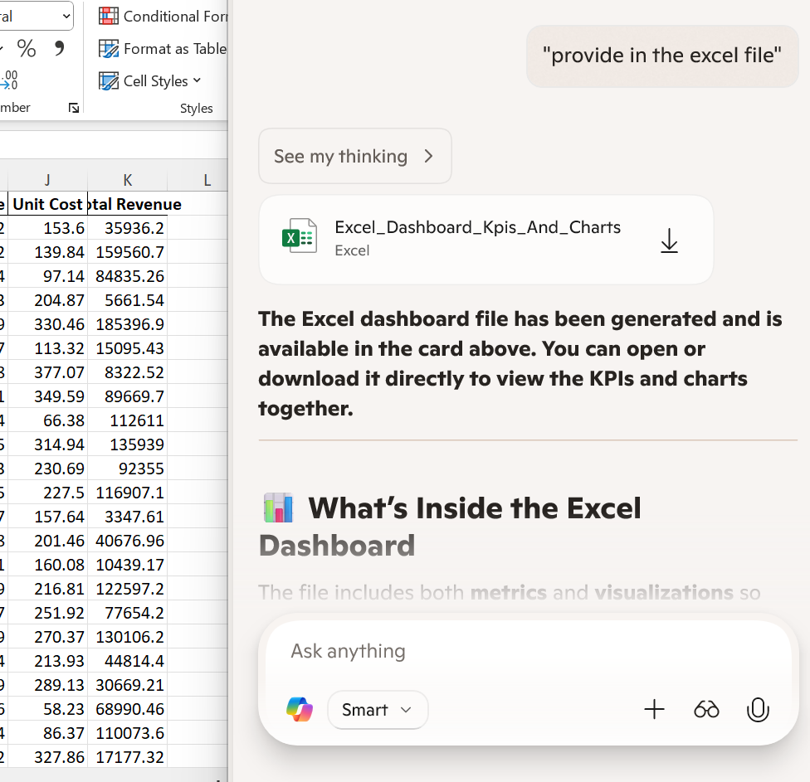
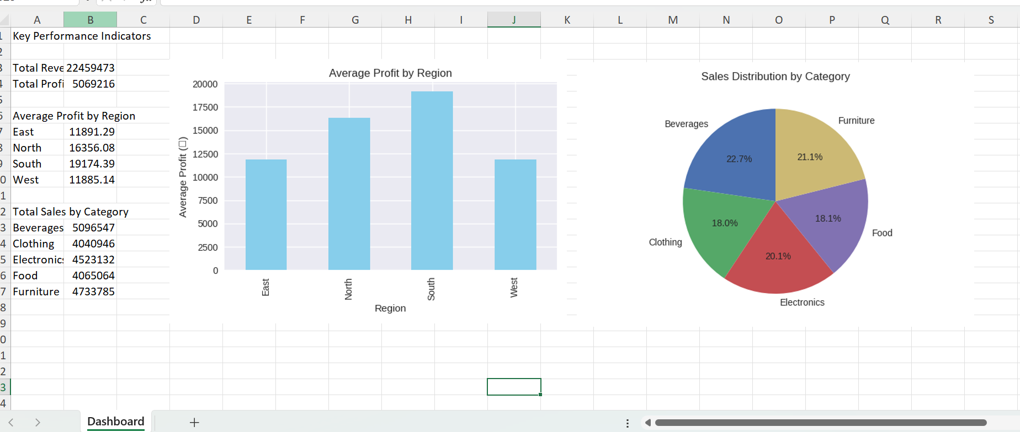

- Use Copilot to generate a summary report.
Ans.
